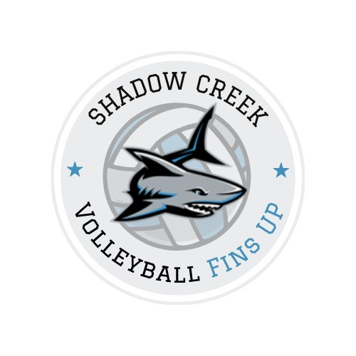
SHADOW CREEK HS VOLLEYBALL CAMP

Monday, July 28th - Wednesday, July 30th
3:30 p.m. to 6:30 p.m.

The 2025 Shadow Creek volleyball camp welcomes all returning players and incoming freshmen who are interested in being a part of the volleyball program for the 2025 season. This camp will be run by All-American Suzy Buechele from the University of Oklahoma and Upside Volleyball Training. Suzy has several years of club coaching experience including two national championships as well as six years of her own high school program. She is currently a counselor at Clear Falls High School. This camp is exclusively for Shadow Creek volleyball athletes in which one-on-one time will be dedicated to the program in its entirety by Suzy and her assistant.

Location: Shadow Creek High School
Camp Fee: $90.00; can be prorated $30 a day if cannot attend all three days.
Payment Method: Cash is preferred
Checks payable to Suzy Buechele
Venmo during registration if the above options do not work
Note: Athletes cannot participate without filling out the attached release form or providing payment. Walk-ins are welcome, but payment must be turned in before they participate.

Please contact: Coach Suzy Buechele at suzy.buechele@gmail.com or
Coach Whitney Daniel at wdaniel@alvinisd.net for any additional questions.
_____________________________________________________________________________________________
2025 Shadow Creek Volleyball Camp Registration Form- please provide with payment.

Player Name: ______________________________ Grade Ent.: ________

Years in the SC Program: _______ What team were you on previously? ___________

Payment Status (please check one):
Check attached: ______ Cash attached: ______ Payment via Coach Daniel: ______

Parent/Guardian Acknowledgement
The undersigned parent and/or guardian does hereby represent that he/she is, in fact, acting in such capacity and agrees to save and hold harmless and indemnify each and all of the parties referred to above of all liability, loss, cost, claim or damage whatsoever which may be imposed upon said activities because of any defect in or lack of such capacity to so act, and release said parties on behalf of the minor and the parents or legal guardian.

By signing, I agree to the above statement. If there is a medical emergency and I cannot be reached, please contact the number below:

Parent/Guardian (print): _____________________________________ Phone #_____________________

Parent/Guardian (sign): ______________________________________

Emergency Name (print): ____________________________________ Phone #_____________________

